Exercise No: 1

Date: 12-10-2020

Aim:

To write a python program to display the calendar for the given year and month.

Program:

import calendar

year=int(input("Enter the Year:"))

month=int(input("Enter the Month:"))

if(1000<=year<=9999 and 1<=month<=12):

print(calendar.month(year,month))

else:

print("Invalid input")

Link:

[http://103.53.53.18/mod/vpl/forms/edit.php?id=229&userid=1706#](http://103.53.53.18/mod/vpl/forms/edit.php?id=229&userid=1706)

Output:

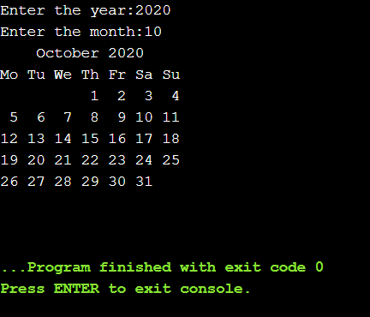

Result:

Thus the calendar for the given month and year was displayed.